DAY-12-MONISHA-SQL
Sales Performance by Region
CREATE TABLE:
CREATE TABLE sale (
order_id int,product varchar(50),
quantity int,
price decimal(10,2),
region varchar(50)
);
INSERT TABLE:
INSERT INTO sale (order_id, product, quantity, price, region)
VALUES
(1, 'Laptop', 3, 50000, 'East'),
(2, 'Mouse', 10, 800, 'West'),
(3, 'Laptop', 2, 52000, 'East'),
(4, 'Keyboard', 6, 1500, 'East'),
(5, 'Monitor', 4, 12000, 'North'),
(6, 'Mouse', 8, 900, 'East');

AGGREGATION:
SELECT region, SUM(price) AS total_sale
FROM sale
GROUP BY region;
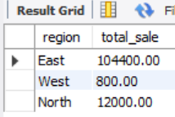

WINDOW FUNTION
SELECT *,
RANK() OVER (ORDER BY total_sales DESC) AS sales_rank
FROM (
SELECT region, SUM(amount) AS total_sales
FROM sales
GROUP BY region
) AS regional_sales;

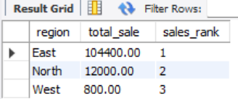

2)Customer Purchase History Analysis
CREATE TABLE:
CREATE TABLE orders (
order_id INT PRIMARY KEY,
customer_id INT,
order_date DATE
);
INSERT INTO:
INSERT INTO orders (order_id, customer_id, order_date) VALUES
(101, 1, '2024-09-10'),
(102, 2, '2024-09-12'),
(103, 3, '2024-09-15'),
(104, 4, '2024-09-17'),
(105, 5, '2024-09-20');
WINDOW FUNCTION(LAG):
WITH ranked_orders AS (
SELECT
customer_id,
order_date,
ROW_NUMBER() OVER (PARTITION BY customer_id ORDER BY order_date) AS order_rank,
LAG(order_date) OVER (PARTITION BY customer_id ORDER BY order_date) AS prev_order_date
FROM orders
)
SELECT
customer_id,
order_date,
prev_order_date,
DATEDIFF(order_date, prev_order_date) AS days_between_first_two
FROM ranked_orders
WHERE order_rank = 2;
Window Function (MAX):
WITH ranked_orders AS (
SELECT
customer_id,
order_date,
ROW_NUMBER() OVER (PARTITION BY customer_id ORDER BY order_date) AS order_rank,
LAG(order_date) OVER (PARTITION BY customer_id ORDER BY order_date) AS prev_order_date,
MAX(order_date) OVER (PARTITION BY customer_id) AS last_order_date
FROM orders
)
SELECT
customer_id,
order_date,
last_order_date,
DATEDIFF(order_date, prev_order_date) AS days_between_first_two
FROM ranked_orders;

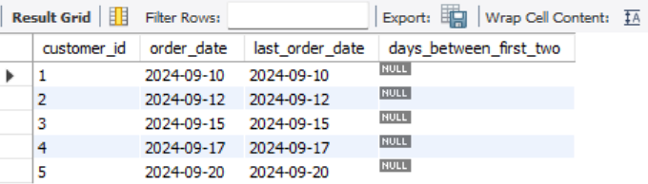

3) Employee Ranking Dashboard
CREATE DASHBOARD:

CREATE TABLE employes (
id INT PRIMARY KEY,
name VARCHAR(100),
department VARCHAR(100),
performance_score DECIMAL(10,2)
);
INSERT INTO:
INSERT INTO employes (id, name, department, performance_score) VALUES
(1, 'Alice', 'Engineering', 85.5),
(2, 'Bob', 'Marketing', 78.0),
(3, 'Charlie', 'Finance', 90.2),
(4, 'David', 'Engineering', 88.0),
(5, 'Emma', 'HR', 70.5);

USING DESNSE RANK():
SELECT
id,
name,
department,
performance_score,
DENSE_RANK() OVER (
PARTITION BY department
ORDER BY performance_score DESC
) AS department_rank
FROM employes
ORDER BY department, department_rank;

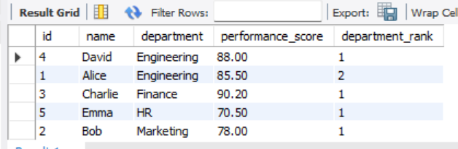

4) Customer Churn Analysis
CREATE TABLE:
CREATE TABLE orders (
order_id INT PRIMARY KEY,
customer_id INT,
order_date DATE
);
INSERT VALUES:
INSERT INTO orders (customer_id, order_date)
VALUES
(1, '2024-09-10'),
(1, '2024-10-05'),
(2, '2024-09-12'),
(2, '2024-11-01'),
(3, '2024-09-15'),
(3, '2024-09-30'),
(4, '2024-09-17'),
(4, '2024-10-25'),
(5, '2024-09-20'),
(5, '2024-12-05');

USING LAG():
SELECT
customer_id,
order_id,
order_date,
LAG(order_date) OVER (PARTITION BY customer_id ORDER BY order_date) AS prev_order_date,
DATEDIFF(order_date, LAG(order_date) OVER (PARTITION BY customer_id ORDER BY order_date)) AS days_between_orders
FROM orders

